Student’s name Teacher’s name

________________________________________ _____________________________



2019
Mathematics 9.5.2
End Semester 2 EXAMINATION

General Instructions  - Total working time –90 minutes  - Write using blue or black pen  Black pen is preferred  - Scientific calculators may be used | Total Marks – 87  - Questions arranged in topics. Attempt questions from all topics.

Section | 1 | 2 | 3 | 4 | Total
 | $$\frac{}{28}$$ | $$\frac{}{26}$$ | $$\frac{}{17}$$ | $$\frac{}{16}$$

Student Comment:

Teacher Comment:
<Surface Area and Volume>
< 28 > marks
Attempt all Questions
Questions <1 to 4> Multiple choice
Allow about 25 minutes for this section

Circle the correct answer for Questions <1 to 4>

1. | If the area of a square field is 16km² the length of one side could be:
 | (A) 32km |  | (B) 2km |  | (C) 8km |  | (D) 4km
2. | The perimeter of this shape is:  3m  10m
 | (A) 30m |  | (B) 26m |  | (C) 13m |  | (D) 7m
3. | The volume of this rectangular prism is:  4m  2m  10m
 | (A) 80m² |  | (B) 16m² |  | (C) 32m² |  | (D) 42m²
4. | The volume of a cylinder with a diameter 12cm and a height of 8cm is closest to:
 | (A) 96cm³ |  | (B) 302cm³ |  | (C) 905cm³ |  | (D) 3619cm³
Questions <5-8> Short Answer. Show all working. Marks are as shown
5. | Convert the following to the units shown:
 |  |  |  |  |  |  |  |  |  |  | Marks
 | a. | 7.93km = ____m |  |  |  |  |  |  |  |  | 1
 | b. | 279mm = _______cm |  |  |  |  |  |  |  |  | 1
 | c. | 36400${mm}^{2}$ = _____${cm}^{2}$ |  |  |  |  |  |  |  |  | 1
 | d. | 0.000435$m^{3}$ = _____${cm}^{3}$ |  |  |  |  |  |  |  |  | 1
6. | A teacher collects some blocks of wood for a classroom activity. Each block is a rectangular prism as shown.  8cm  6cm  20cm
 |  |  |  |  |  |  |  |  |  |  | Marks
 | a. | Find the volume of one block. |  |  |  |  |  |  |  |  | 1
 | b. | The blocks will be painted on all sides. Find the total surface area for one block in cm². |  |  |  |  |  |  |  |  | 3
 | c. | Paint costs $2.30 per 100cm². Find the cost of painting 8 blocks. |  |  |  |  |  |  |  |  | 2
 | d. | Calculate the volume and surface area of the following triangular prism:  b) Surface Area:  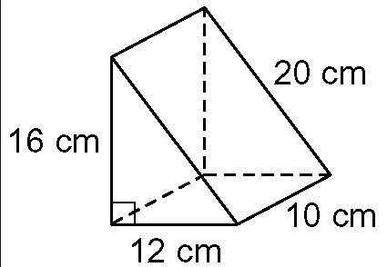  a) Volume:  Compare the volume and surface area of this block to the rectangular one above? |  |  |  |  |  |  |  |  | a) 2  b) 2  2
7. | Calculate the area of the following shapes: (to 2 decimal places)
 | a) Find the area of the Sector: |  |  |  |  |  |  |  |  | Marks
 | 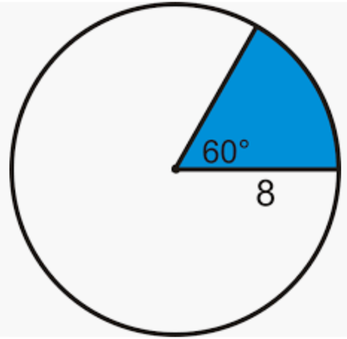 |  |  |  |  |  |  |  |  | 2
 | b) Determine the total area of this composite shape:
 | 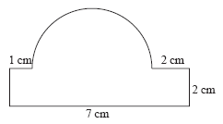 |  |  |  |  |  |  |  |  | 3
8.
 |  |  |  |  |  |  |  |  |  | Marks
 | How many litres of gas can a tanker carry if its tank is cylindrical with a diameter of 2.8m and is 11m in length? Round your answer to the nearest L. (1m³ = 1000L) |  |  |  |  |  |  |  |  | 3
<Indices>
< 26 > marks
Attempt all Questions
Questions <9 to 12> Multiple choice
Allow about 25 minutes for this section

Circle the correct answer for Questions <9 to 12>

9. | 2g² × 3g⁴ =
 | (A) 6g⁸ |  | (B) 5g⁶ | (C) 6g⁶ |  | (D) 5g⁸
10. | 7(5mn²)⁰
 | (A) 1 |  | (B) 35mn² | (C) 75mn²⁰ |  | (D) 7
11. | (3b³)²
 | (A) 9b⁶ |  | (B) 6b⁵ | (C) 9b⁵ |  | (D) 6b⁶
12. | The mass of a shipping container is 3.42 × 10³ kg. This mass in kilograms is:
 | (A) 342kg |  | (B) 342000kg | (C) 3420kg |  | (D) 0.00342kg
Questions <13-15> Short Answer. Show all working. Marks are as shown

13.
 |  |  |  |  |  |  |  |  | Marks
 | a. | x⁴ × x⁷ = |  |  |  |  |  |  | 1
 | b. | (g³)⁵ = |  |  |  |  |  |  | 1
 | c. | Write with positive indices:  p⁻² = |  |  |  |  |  |  | 1
14.
 |  |  |  |  |  |  |  |  | Marks
 | a. | 3a³ b⁵ c × 6a⁶b = |  |  |  |  |  |  | 2
 | b. | x¹² y⁷ ÷ (x² y)⁴ = |  |  |  |  |  |  | 2
 | c. | $\frac{10w^{5}y^{4}}{{5w}^{3}y}$ = |  |  |  |  |  |  | 2
 | d. | $\frac{5k^{4}m^{5}}{25k^{7}mn}$ = |  |  |  |  |  |  | 3
 | e. | (3ab⁴)³ = |  |  |  |  |  |  | 2
 | f. | Solve and write with positive indices:  (2g³h⁻²)⁻³$×$ 2gh³ |  |  |  |  |  |  | 3
15.
 |  |  |  |  |  |  |  | Marks
 | Convert the following to scientific notation:  a) 457000 b) 0.000000000456 |  |  |  |  |  |  | 2
 | Calculate the number of seconds in 1 year.  Write your answer using scientific notation, correct to 3 significant figures. |  |  |  |  |  |  | 3
<Right Angled Triangles>
<17> marks
Attempt all Questions
Questions <16 to 19> Multiple choice
Allow about 20 minutes for this section
Circle the correct answer for Questions <16 to 19>

16. | Which side is the Hypotenuse:  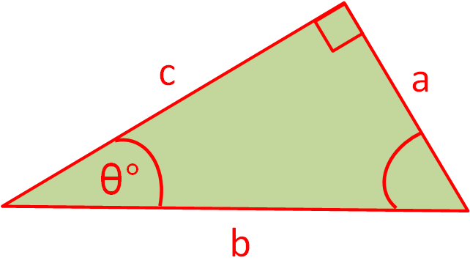
 | (A) a |  | (B) b | (C) c |  | (D) There is no Hypotenuse
17. | Which fraction is equal to Cos( t ):  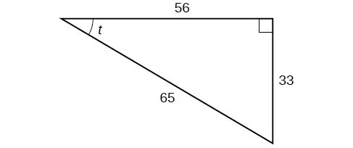
 | (A) $\frac{56}{65}$ |  | (B) $\frac{33}{65}$ | (C) $\frac{56}{33}$ |  | (D) $\frac{33}{56}$
18. | Which equation represents Pythagoras’ Theorem for the following Triangle:  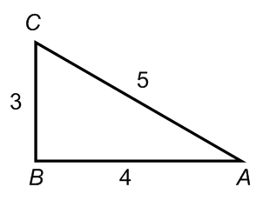
 | (A) $5^{2}=\sqrt{3^{2}+4^{2}}$ |  | (B)$5$ = $\sqrt{3^{2}-4^{2}}$ | (C) $5^{2}$= $3^{2}{- 4}^{2}$ |  | (D)$5= \sqrt{3^{2}+4^{2}}$
19. | Find the value of $θ$, if sin$θ=0.5$
 | (A) 60$°$ |  | (B) 30$°$ | (C) 90$°$ |  | (D) 45$°$
Questions <20-22> Short Answer. Show all working. Marks are as shown

20.
 |  |  |  |  |  |  |  |  | Marks
 | a. | Calculate the length of the side ‘h’:  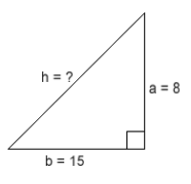 |  |  |  |  |  |  | 2
 | b. | Find the value of the pronumeral, a:  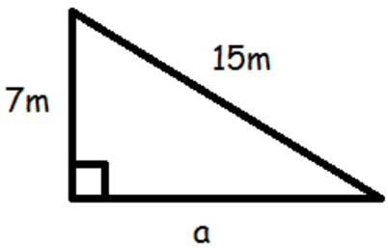 |  |  |  |  |  |  | 2
21.
 |  |  |  |  |  |  |  |  | Marks
 | a. | Find the value of y and g, correct to 2 decimal places:  sin 54$°$ = $\frac{y}{12}$ tan 30$°$ = $\frac{18}{m}$ |  |  |  |  |  |  | 2
 | b. | Calculate the value of the pronumeral, x:  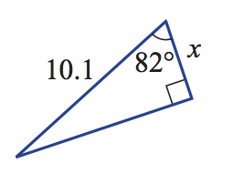 |  |  |  |  |  |  | 2
 | c. | Determine the value of the pronumeral, x:  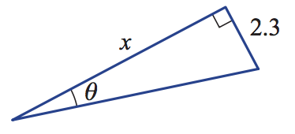 |  |  |  |  |  |  | 2
22.
 |  |  |  |  |  |  |  | Marks
 | From a point on the ground, Liana measures the angle of elevation of an 140m tower to be 34$°$.  i) Draw a diagram to represent this information.  ii) Find how far Liana is from the base of the tower, correct to the nearest metre. |  |  |  |  |  |  | 3

<Linear Relationships>
<16> marks
Attempt all Questions
Questions < 23 to 26> Multiple choice
Allow about 20 minutes for this section

Circle the correct answer for Questions <23 to 26>

23. | The line $y=7x +3$ has a y-intercept of:
 | (A) b = -7 |  | (B) b = -3 | (C) b = 3 | (D) b = 7
24. | Determine the gradient of the following line:  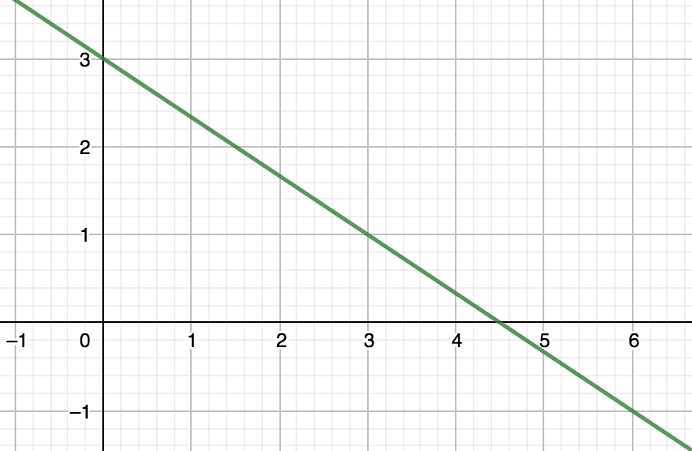
 | (A) m = $-\frac{3}{2}$ |  | (B) m = $\frac{3}{2}$ | (C) m = $\frac{2}{3}$ | (D) m = $-\frac{2}{3}$
25. | For the line$y=-3x+2$, the value of y when x = 2 is:
 | (A) y = -8 |  | (B) y = -4 | (C) y = -30 | (D) y = -6
26. | What is the equation of the line:  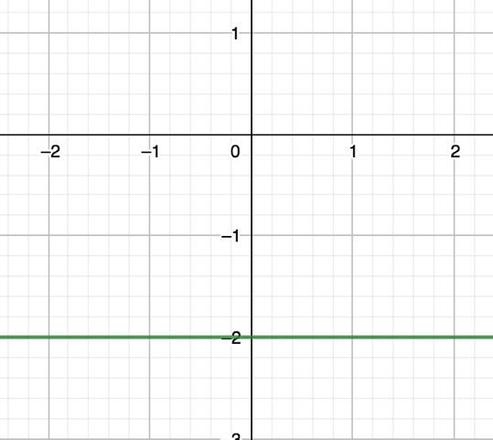
 | (A) y = -2 |  | (B) y = -2x | (C) y = x - 2 | (D) x = -2
Questions <27 and 28 > Short Answer. Show all working. Marks are as shown

27.
 |  |  |  |  |  | Marks
 | a. | Plot the point, A, at (-3, -2) on the plane below:  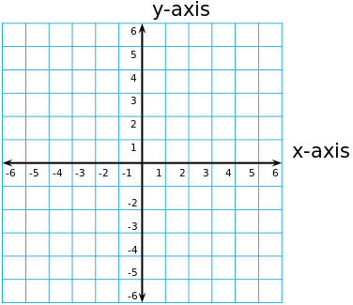 |  |  |  | 1
 | b. | Plot a point, B, in the first quadrant above and state the co-ordinates of point B. Calculate the distance between point A and point B. |  |  |  | 3
 | c. | Calculate the midpoint between points A and B: |  |  |  | 2
 | d. | Determine the gradient of the line joining point A and B:  Determine the y-intercept of the line joining point A and B:  State the equation of the line which connects points A and B: |  |  |  | 1  1  1
28.
 |  |  |  |  |  | Marks
 | a. | Plot the following line by finding the x and y intercepts: $y=2x-3$   |  |  |  | 3

END OF EXAM

